Info on Maximillian Blue
Max’s Sire
SG NC PromisedLand RC Bonafide +*S ++*B
Elite Status Buck
Chocolate Buckskin, Swiss Marked, Moon Spotted
ADGA Super Genetics Designation
GRS: +B ARMCH Rosasharns Tiger L ++ *S E
Sire: Rosasharn TL Cauldron *S
GRD: Rosasharns UK Witch Hazel 5*D VG AR1851
GRS: +B NC PromisedLand MG Beau +*S
Dam: ARMCH NC PromisedLand Beau-Nita E 3*D 2*M
1 X BIS 14 X BOB 3 X GCH 16 X Best Udder, 2008 Breed Leader -
#1milk production with both ADGA & AGS
GRD: GCH ARMCH PromisedLand GoodDay SunShine 2*D *M E90

Sire picture
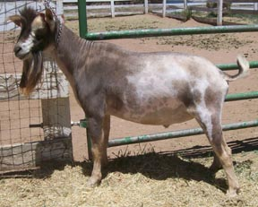
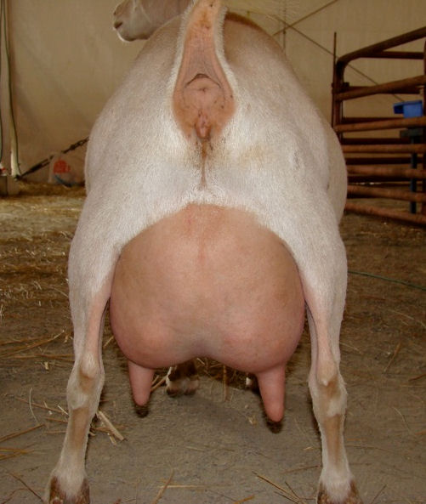
Sire’s Dam picture
Pictures by Lora Kniffin

Max’s Dam
GCH/MCH Prairie Wood Bella *D/1*M VG
DOB: 5-24-06
MCH/CH in Both ADGA & AGS
3xs Best Udder
Sire: Kaapio Acres BT Racketeer +*S +*B
Dam: MK Blanca
Blue Eyes
Milking Stars

Dam’s Picture

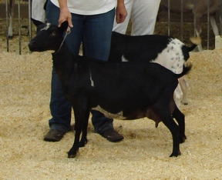

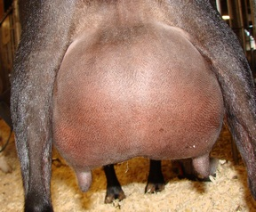
Dam’s Udder
Pictures by Lora Kniffin

